ORGAN DONATION
ORGAN DONATION (organ-donation-pb.netlify.app)
-PIYUSH BHATNAGAR

TECHNOLOGIES USED :-
- BLOCKCHAIN
- MERN STACK

SUMMARY of the project
I made a online platform where donors can register and then to get approved, they have to visit nearby hospitals. Then hospitals will see their aadhar card and approve them.
Users can check status of donors by using their aadhar card whether the donor has found a matching recipient.
Hospitals can login and then approve the donors. They can register recipients/patients who want organs. They can find match for recipients in the available donors.
This website also offers a feature for public to donate money for charity purposes. All the donors names will be visible on the website to motivate others.

WORKFLOW :-
METAMASK CONNECTION IS COMPULSARY FOR HOSPITALS BECAUSE THEY ARE THE ONES WHO ARE ACCESSING AND WRITING ON BLOCKCHAIN.
- Donor has to register.
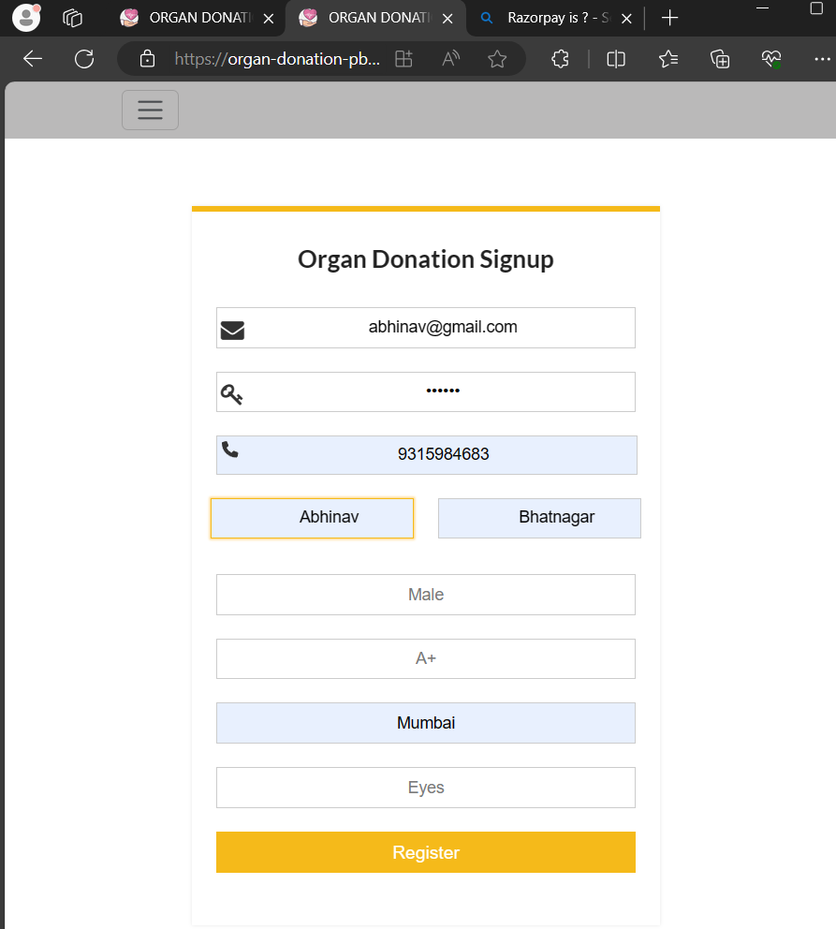

Then they will see a list of hospitals acc. to their selected city.
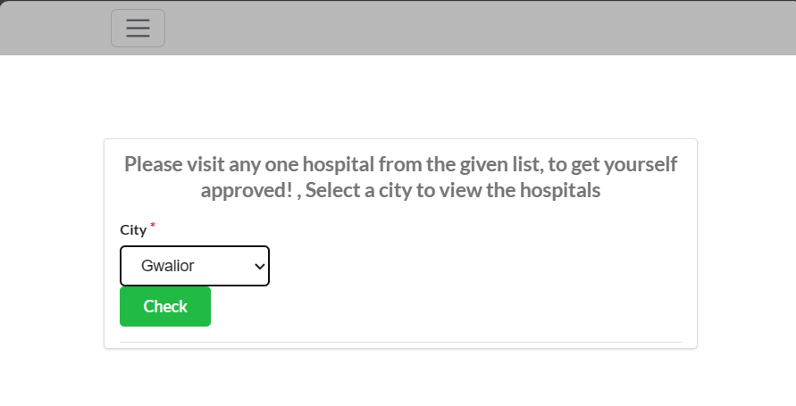
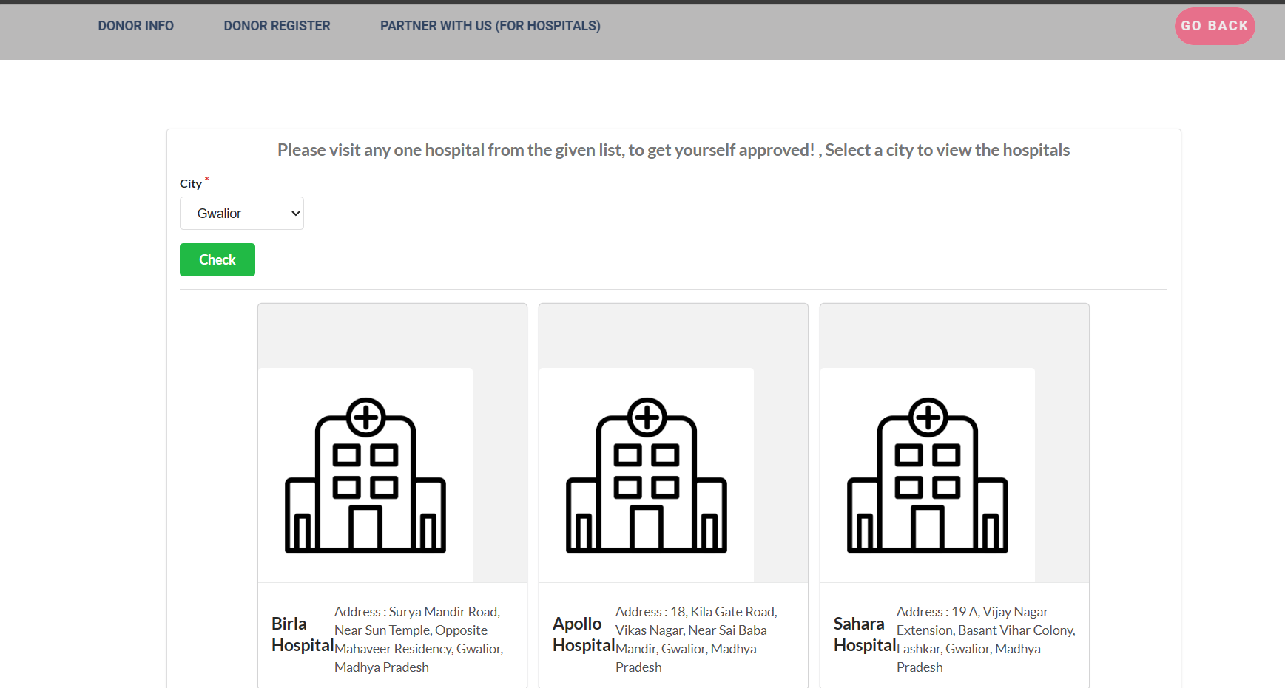

- Hospitals have to login.
(username: AIIMS_Delhi, password: 1234)

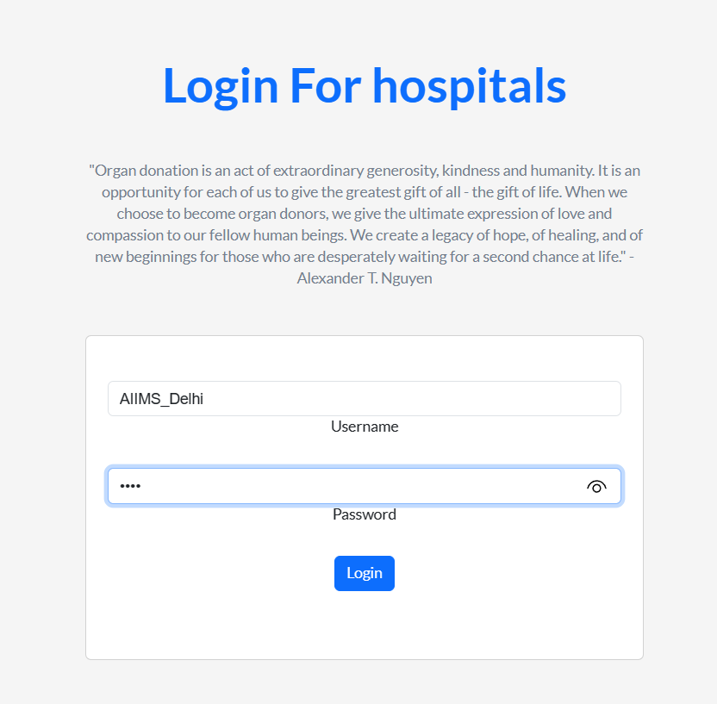

- Hospital can approve the registered donors by entering their email and aadhar number.
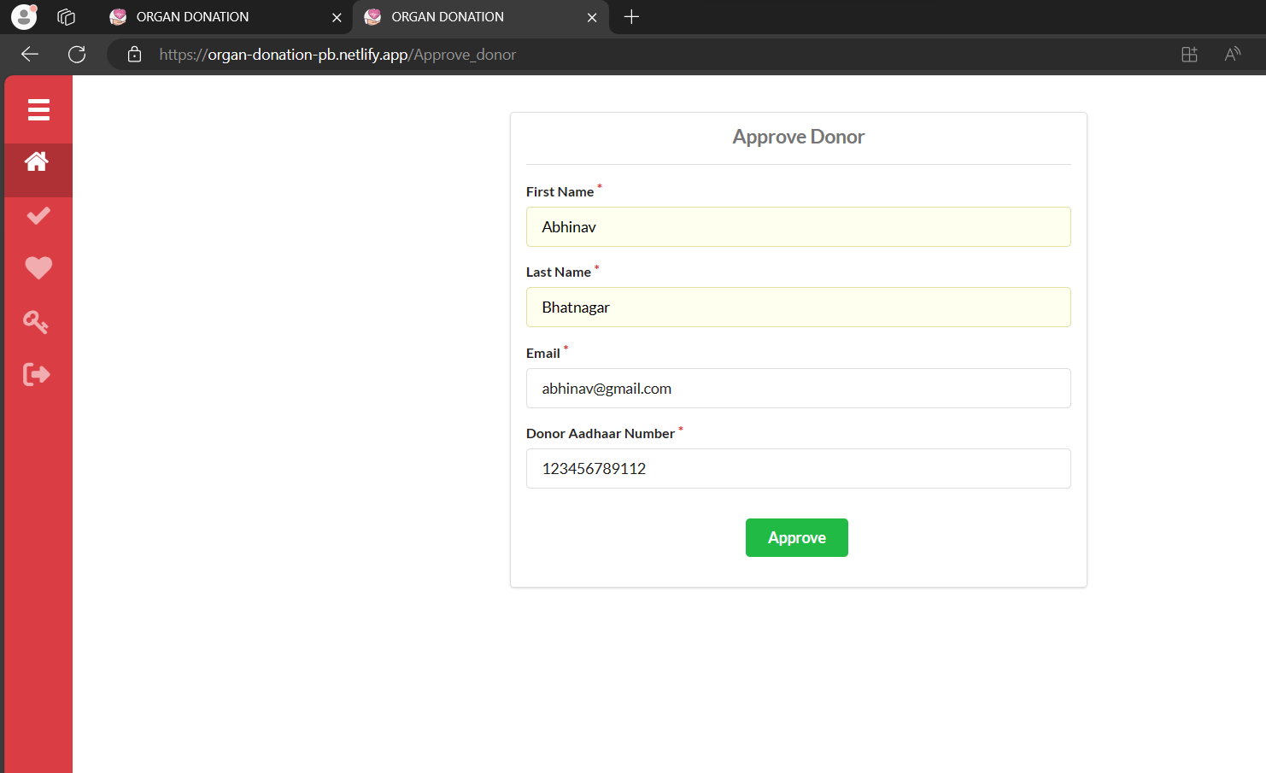
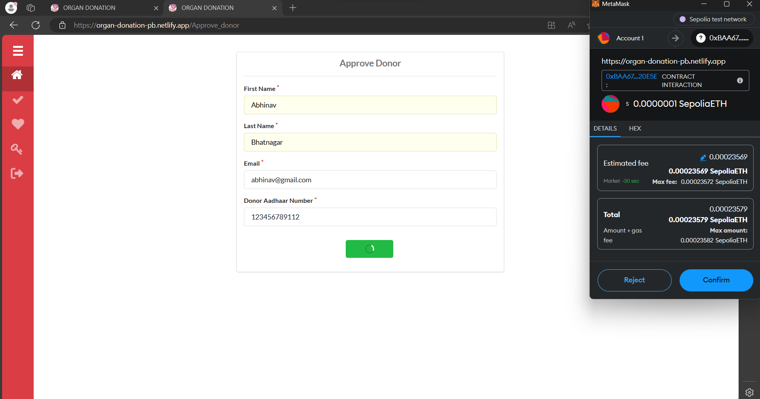
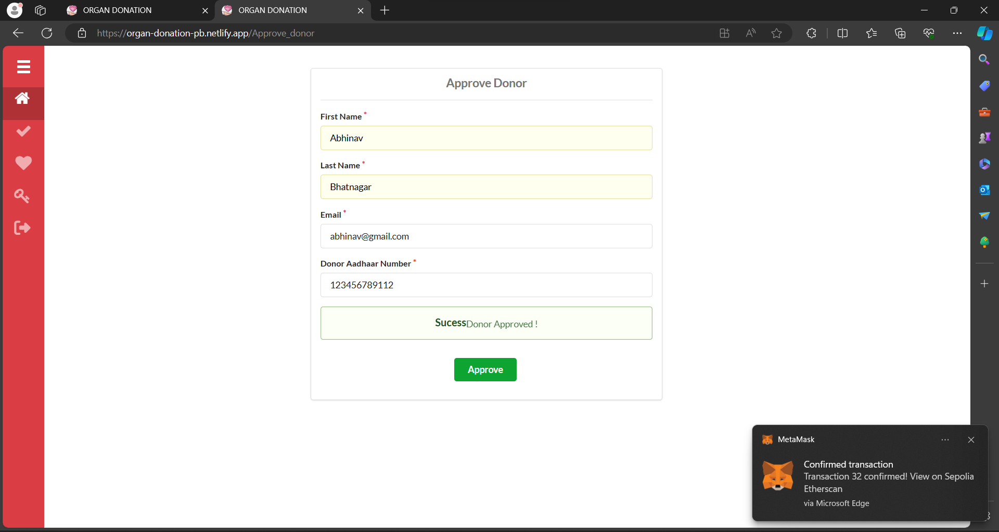

- Hospitals can register recipients.

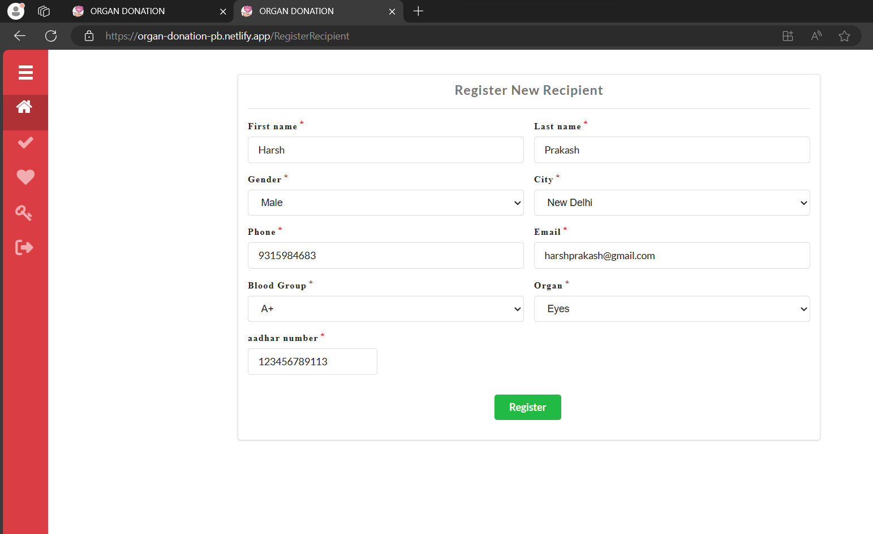
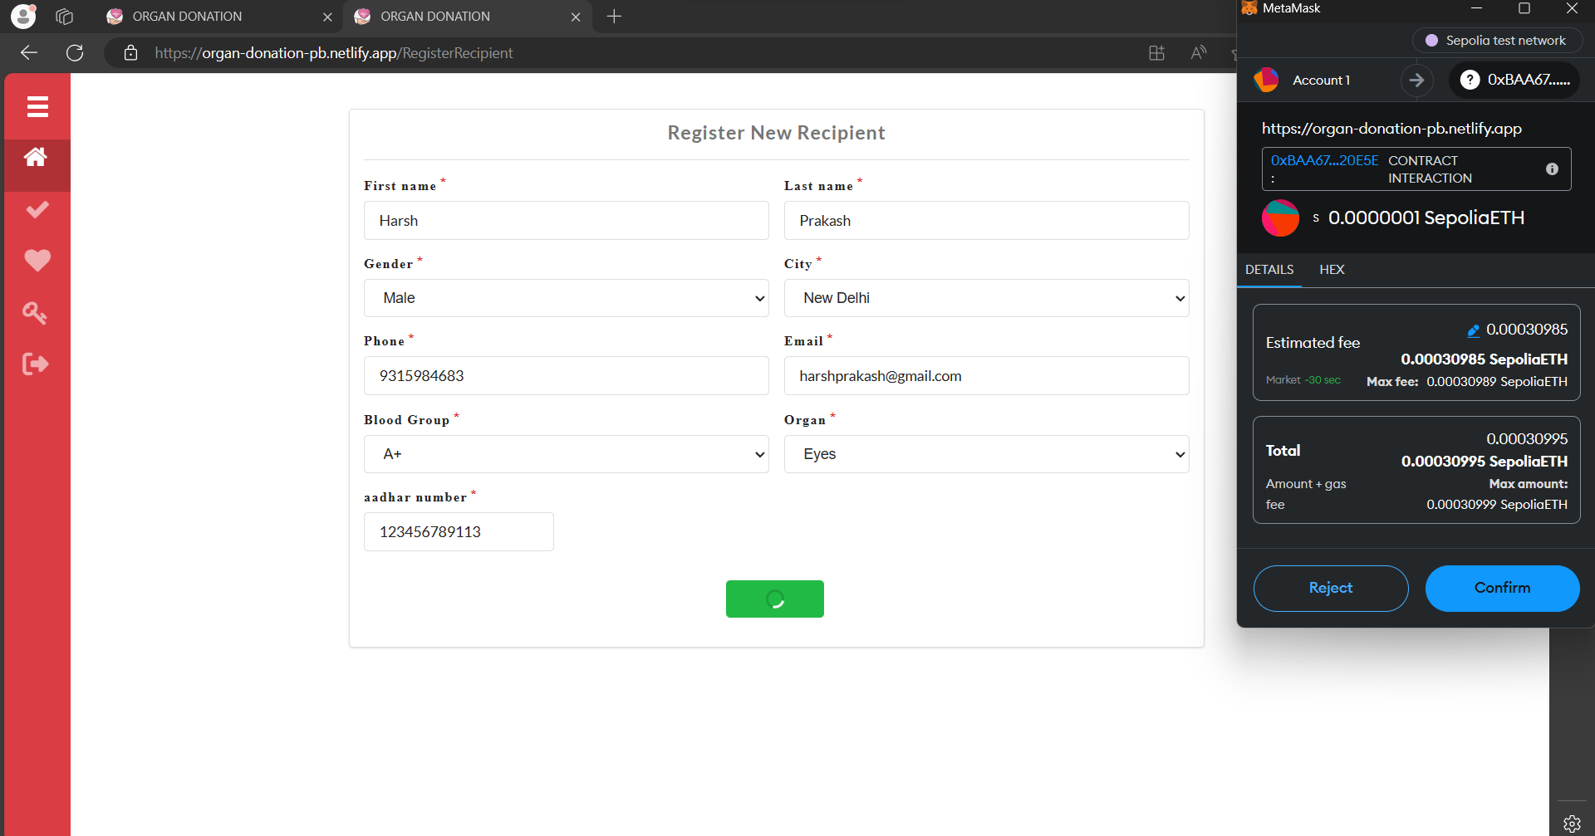
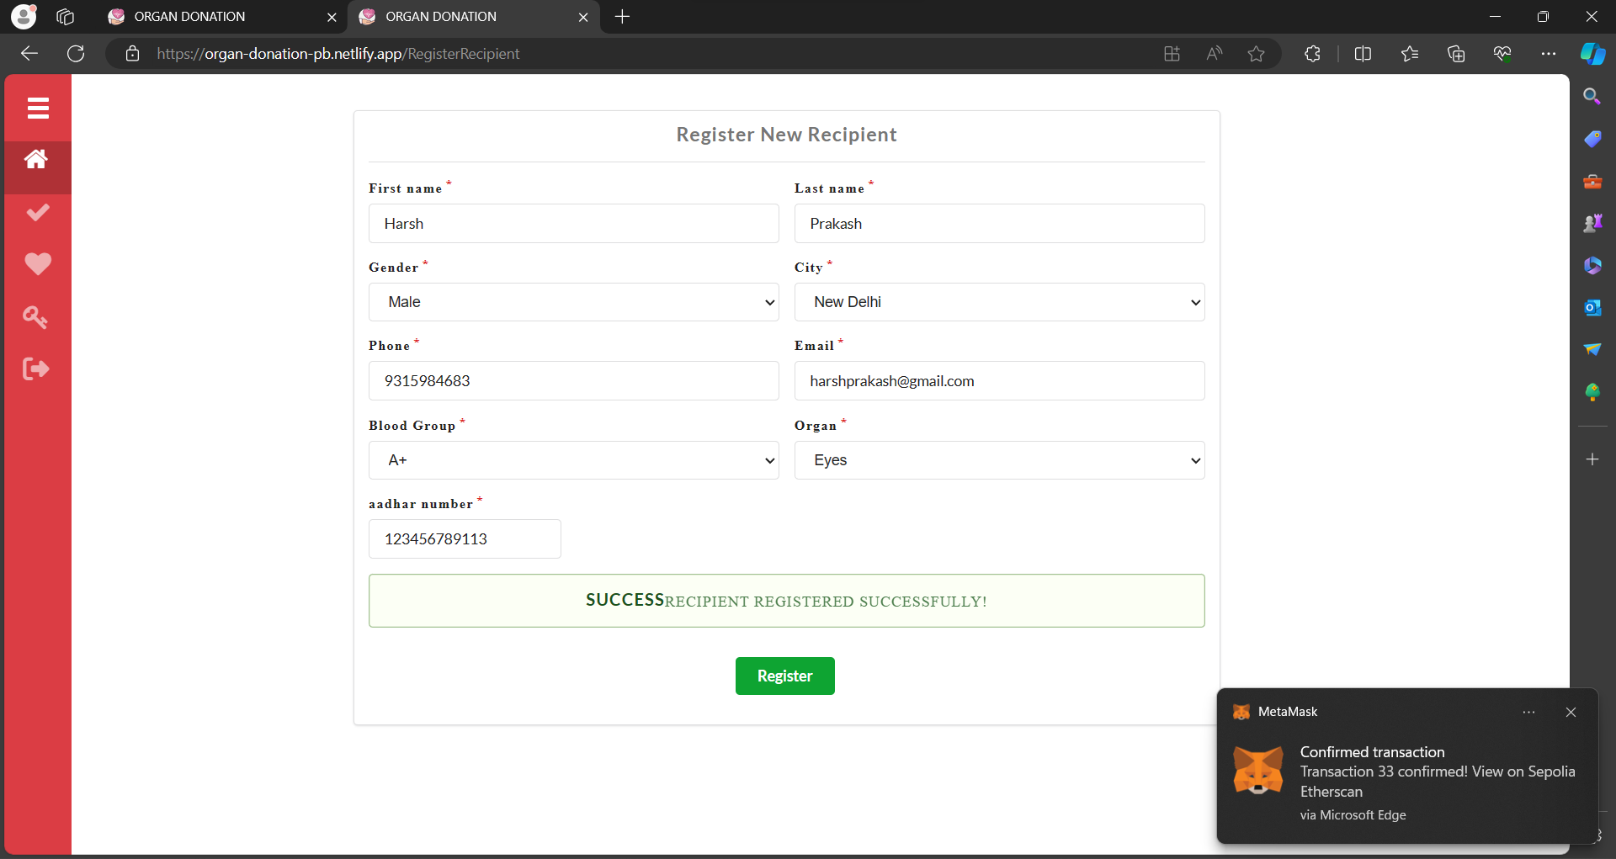

- Hospitals can see available recipients and can match them with available donors to find match.
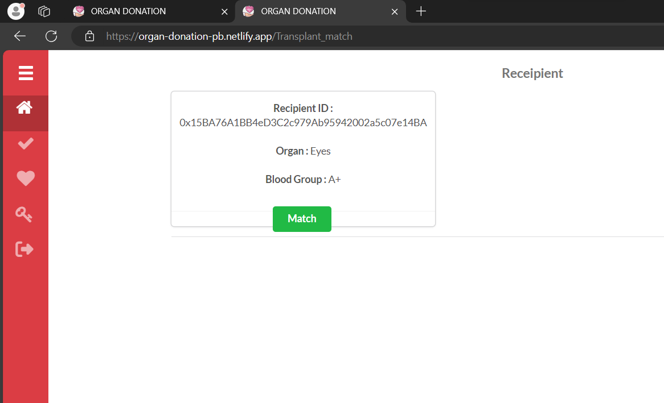
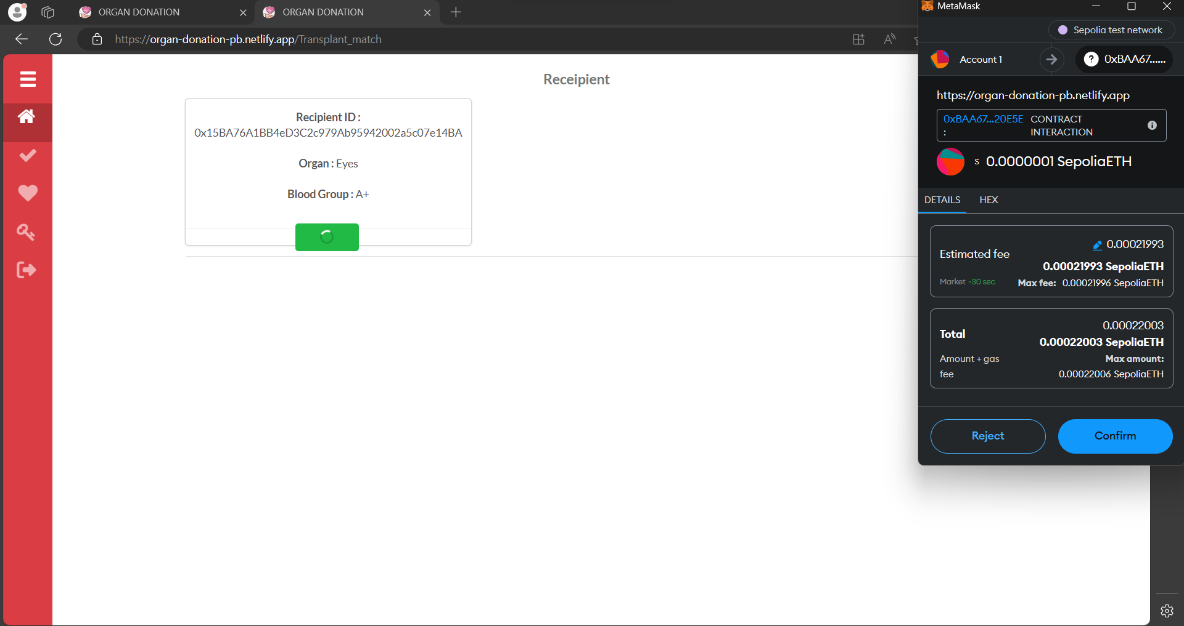
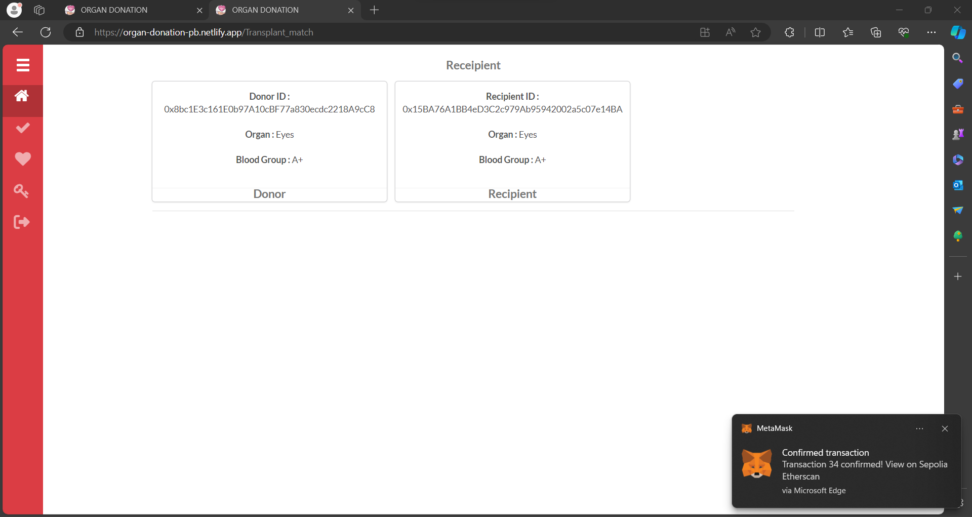

So, recipient is matched with a Donor !!

- Users can see status of Donors.
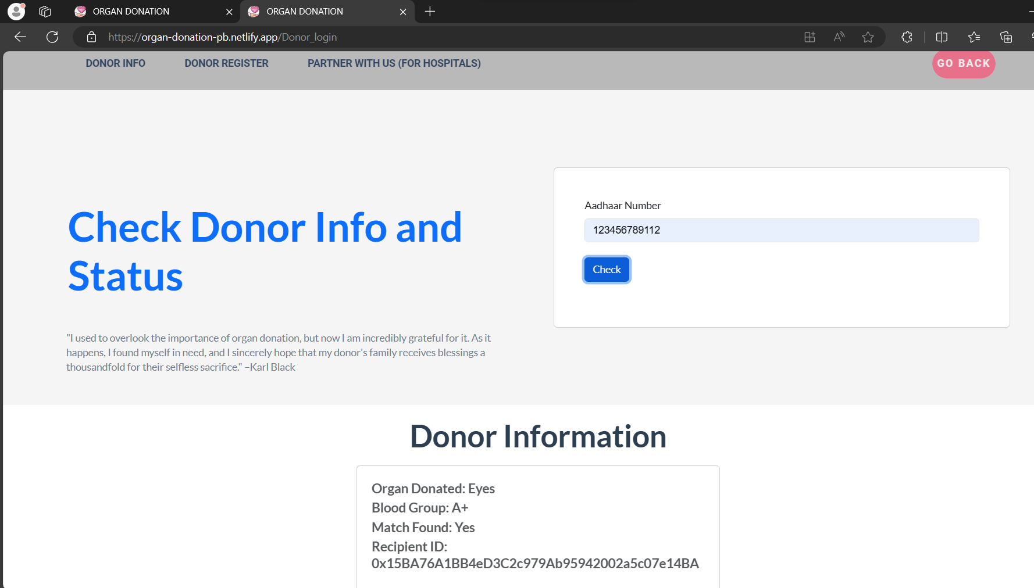

- User can donate money for charity using razorpay.
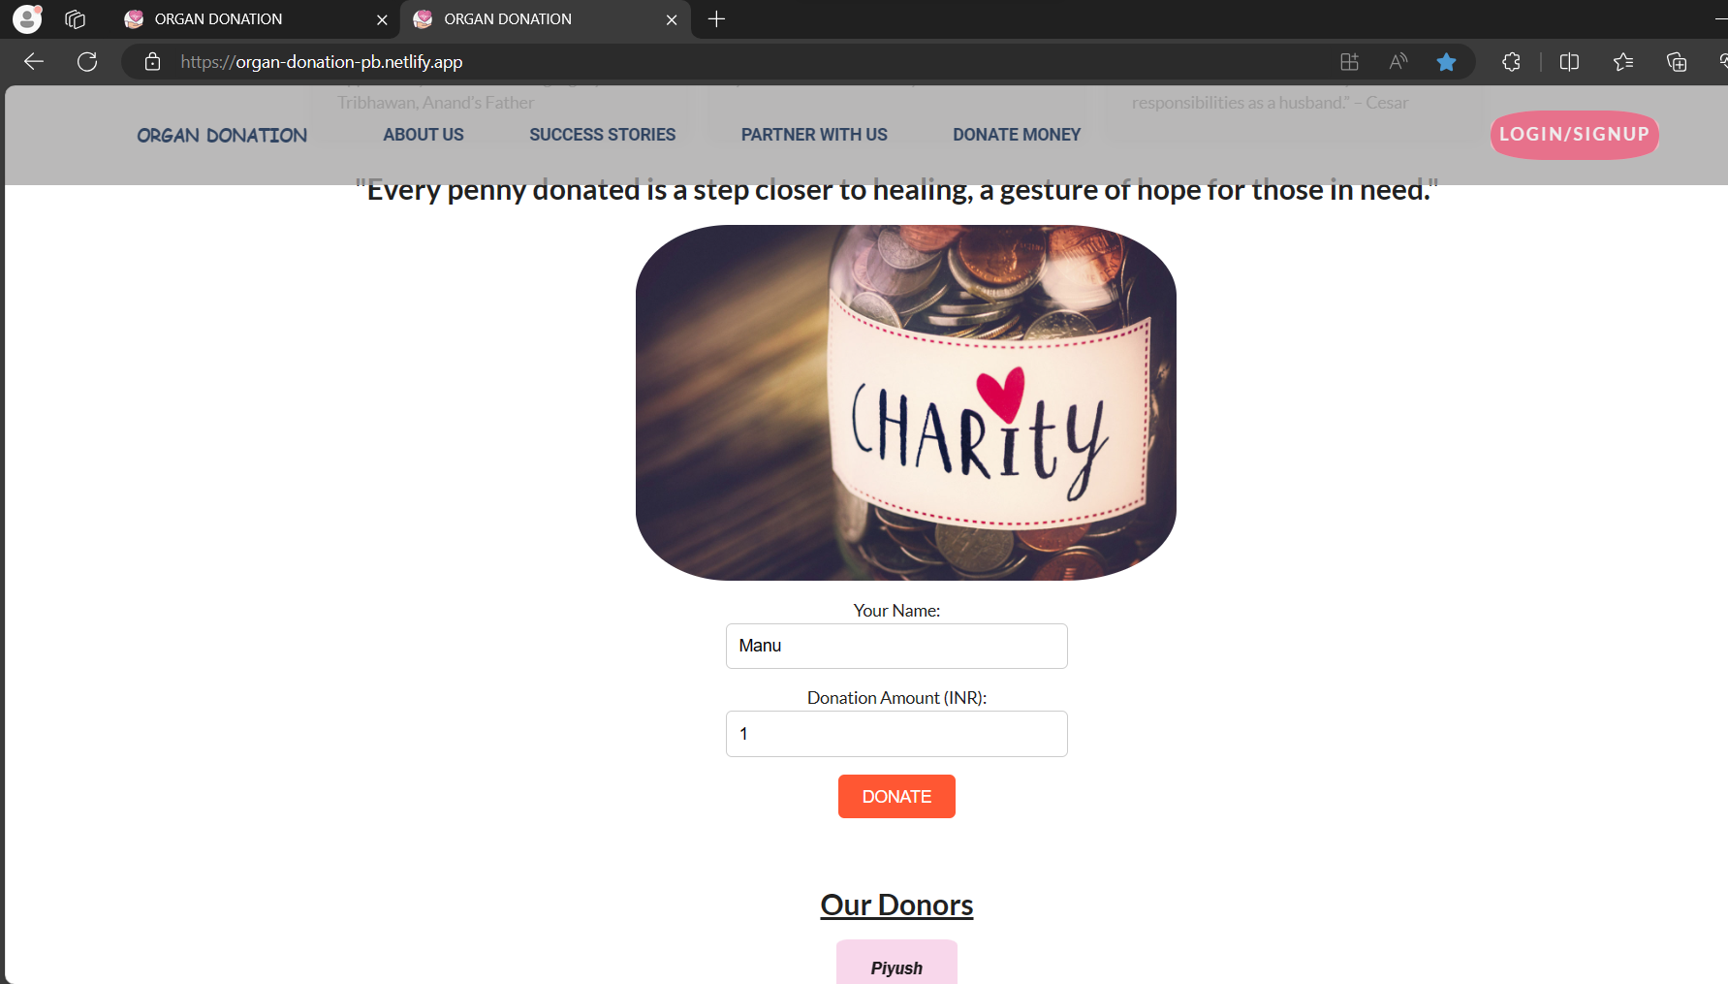
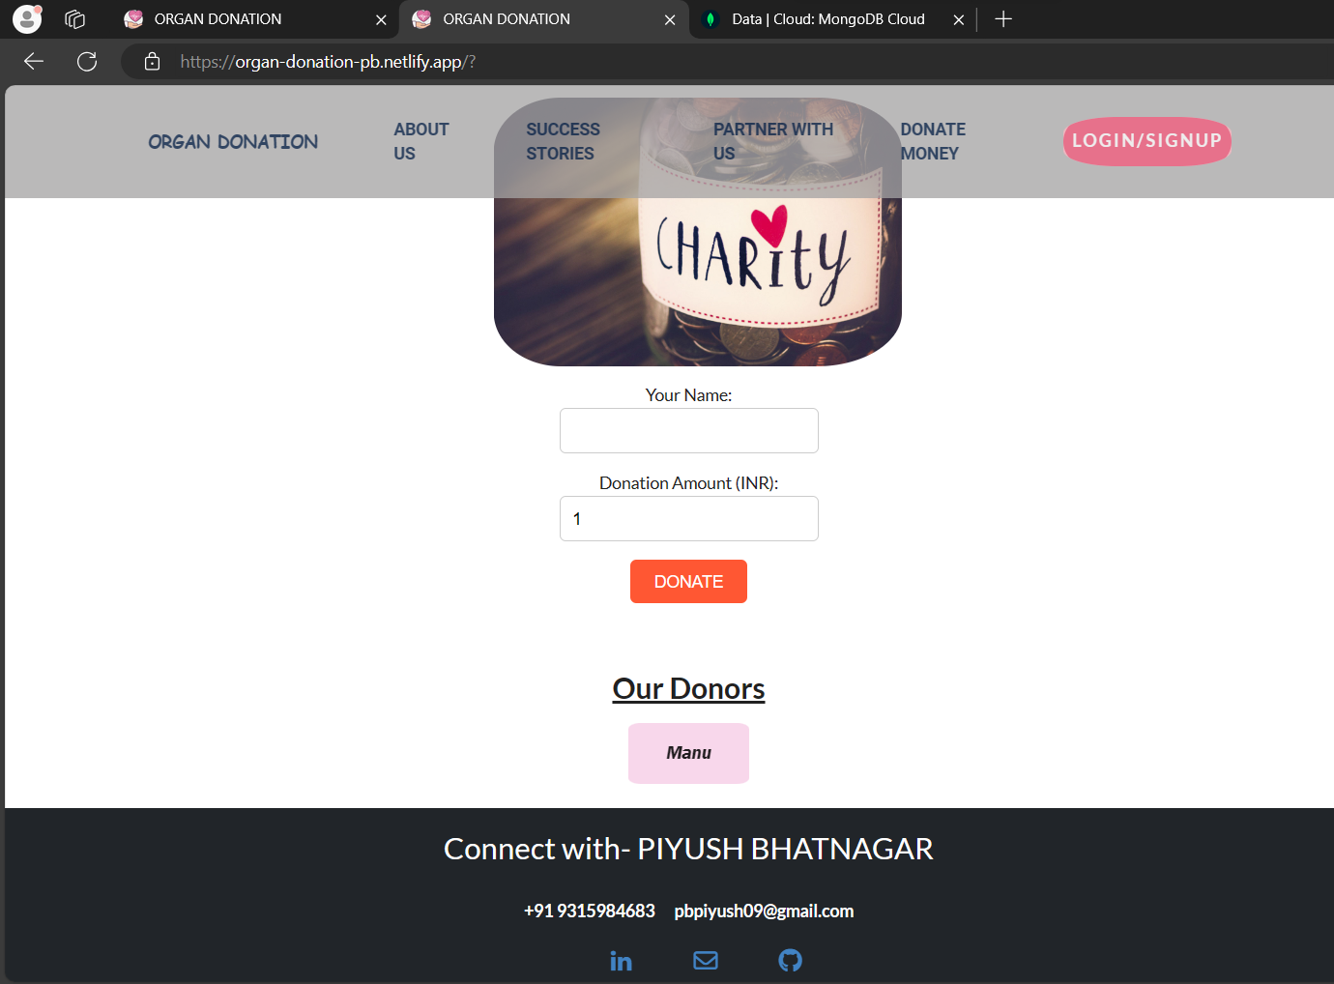

MODELS IN MONGODB:-
- Donor
  - Firstname. Lastname, gender, city, phone, email. Bloodgroup, organ, password
- Hospital
  - Username, password, hospitalpublickey, address, contact, city, img
- Money donor
  - Name

IMPORTANT POINTS :-
- When donors register, there info is stored in mongodb database. When they are approved by hospital then there info is written in blockchain by hospital.

CONTRACT :
- We have used Aadhar Number for unique id of recipient and donor.
  - const hash = sha3.keccak256(this.state.aadhaarNumber);: It calculates the Keccak-256 hash of the value stored in this.state.aadhaarNumber using the sha3 library. Keccak-256 is a cryptographic hash function used in Ethereum for various purposes.
  - const addressBytes = hash.slice(-40);: It takes the last 40 characters (which represent 20 bytes in hexadecimal format) of the hash computed in the previous step. Ethereum addresses are 20 bytes long.
  - const address = '0x' + addressBytes.toString('hex');: It converts the 20 bytes obtained in the previous step into a hexadecimal string and prepends it with '0x', which is a common prefix for Ethereum addresses.
  - const checksumAddress = web3.utils.toChecksumAddress(address);: It converts the hexadecimal Ethereum address obtained in the previous step into a checksum address. Checksum addresses include a checksum to help prevent address typos. The toChecksumAddress function from the web3 library performs this conversion.

- Contract has 3 structures to store information of Recipient, Donor, Transplant.
- Functions :
  - addDonor
  - getDonor using his aadhar number
  - addRecipient
  - getRecipient using address
  - getRecipientCount using hospital address
  - getMatchedDonor using recipient address
  - transplantMatch using recipient address (by matching organ and blood group)

QUESTIONS :-
Q. WHY USED BLOCKCHAIN?
- Because data is stored on blockchain, so data is immutable and transparent.
- If we use a centralized system then hospital can change their database, if they involved in some illegal activity like selling organs in Black Market.
- Data is never lost, no one can hack or manipulate blockchain (how? Why?)
  - Because if a node is changed then all next nodes corrupt, so blockchain is changed. Other nodes will see that blockchain is not matching. So, the blockchain which is on majority computers will be overwritten again on that node.

Q. Why prefer MongoDB over other databases?
MongoDB is often preferred for its flexibility and scalability, particularly in applications where the data structure is expected to evolve over time or where there are large volumes of unstructured or semi-structured data. Its document-oriented model allows for easy storage and retrieval of complex data structures, making it suitable for use cases like content management systems, real-time analytics, and mobile app development.
Q. Which is better, SQL or NoSQL database? What is difference between them?
The choice between SQL (relational) and NoSQL (non-relational) databases depends on the specific requirements of the project. SQL databases are known for their structured data model, ACID transactions, and strong consistency guarantees, making them suitable for applications with complex relationships between data entities, such as banking systems or enterprise resource planning (ERP) software. On the other hand, NoSQL databases offer more flexibility and horizontal scalability, making them ideal for handling large volumes of data with varying schemas, like social media platforms, IoT applications, and real-time analytics systems. The main differences lie in their data models, consistency models, scalability options, and query languages.
- Proof of Work (PoW) is a consensus mechanism in blockchain where miners compete to solve complex puzzles to validate transactions and add new blocks to the chain. The first miner to solve the puzzle gets to add the block and receives a reward.
Q. What are limitations in using Blockchain?
Despite its benefits, blockchain technology has several limitations, including scalability issues, high energy consumption (particularly in proof-of-work consensus mechanisms), regulatory uncertainties, limited transaction throughput, potential privacy concerns (depending on the implementation), and complexity in governance and interoperability. Additionally, blockchain networks may be susceptible to security vulnerabilities, such as 51% attacks or smart contract bugs.
Q. Why used ReactJS? Why not any other framework?
ReactJS is preferred by many developers for its component-based architecture, virtual DOM rendering, and efficient updates, which result in faster and more responsive user interfaces. It also offers a rich ecosystem of libraries, tools, and community support. The choice of ReactJS over other frameworks depends on factors such as project requirements, team expertise, performance considerations, and developer preferences.
Q. Where you used expressJS?
ExpressJS is commonly used as a backend web application framework for Node.js. It simplifies the process of building APIs, handling HTTP requests, routing, and middleware integration. Developers often use ExpressJS to create RESTful APIs or server-side applications, serving as the backend component in full-stack JavaScript development. It's particularly popular for its minimalistic design, flexibility, and ease of use.
Q. Can we do all the sql work in NoSql also?
No, you cannot perform all SQL work in NoSQL databases. SQL (Structured Query Language) and NoSQL (Not Only SQL) databases have fundamentally different data models and query languages, which means they excel in different types of tasks.
SQL databases, also known as relational databases, are designed for structured data with predefined schemas and support complex queries involving joins, aggregations, and transactions. They are suitable for applications that require strong consistency guarantees and complex relationships between data entities.
On the other hand, NoSQL databases are optimized for handling unstructured or semi-structured data and offer more flexibility in data modeling. They typically use query languages that are tailored to specific use cases, such as document-oriented queries for MongoDB or graph queries for Neo4j. While NoSQL databases may provide some querying capabilities, they often lack the full range of features and expressiveness offered by SQL databases.
In summary, while some tasks performed in SQL databases can be accomplished in NoSQL databases, there are limitations and differences in functionality due to the distinct nature of their data models and query languages. It's important to choose the appropriate database technology based on the specific requirements and characteristics of the application.

